МИНОБРНАУКИ РОССИИ
Санкт-Петербургский государственный
электротехнический университет
«ЛЭТИ» им. В.И. Ульянова (Ленина)
Кафедра вычислительной техники

отчет
по лабораторной работе №6
по дисциплине «Web-программирование»
Тема: АУТЕНТИФИКАЦИЯ И АВТОРИЗАЦИЯ ПОЛЬЗОВАТЕЛЕЙ
web-ПРИЛОЖЕНИЯ

Студент гр. 4312 |  | Устинов М.Д.
Преподаватель |  | Павловский М.Г.

Санкт-Петербург
2026

Цель работы: знакомство со способами реализации аутентификации и
авторизации пользователей web-приложения.
Порядок выполнения лабораторной работы:
1. Создать Maven-проект с web-приложением аналогичным, лабораторной работе № 5.
2. Настройте web-сервер на базовую аутентификацию.
3. Запустить приложение с указанием имени пользователя и пароля.
4. Настроить web-сервер на протокол SSL и запустить приложение,
используя защищенный порт.

Распечатка файлов tomcat-users.xml, web.xml и server.xml.
<?xml version="1.0" encoding="UTF-8"?>
<!--
Licensed to the Apache Software Foundation (ASF) under one or more
contributor license agreements. See the NOTICE file distributed with
this work for additional information regarding copyright ownership.
The ASF licenses this file to You under the Apache License, Version 2.0
(the "License"); you may not use this file except in compliance with
the License. You may obtain a copy of the License at

http://www.apache.org/licenses/LICENSE-2.0

Unless required by applicable law or agreed to in writing, software
distributed under the License is distributed on an "AS IS" BASIS,
WITHOUT WARRANTIES OR CONDITIONS OF ANY KIND, either express or implied.
See the License for the specific language governing permissions and
limitations under the License.
--><tomcat-users version="1.0" xmlns="http://tomcat.apache.org/xml" xmlns:xsi="http://www.w3.org/2001/XMLSchema-instance" xsi:schemaLocation="http://tomcat.apache.org/xml tomcat-users.xsd">
<!--
By default, no user is included in the "manager-gui" role required
to operate the "/manager/html" web application. If you wish to use this app,
you must define such a user - the username and password are arbitrary.

Built-in Tomcat manager roles:
- manager-gui - allows access to the HTML GUI and the status pages
- manager-script - allows access to the HTTP API and the status pages
- manager-jmx - allows access to the JMX proxy and the status pages
- manager-status - allows access to the status pages only

The users below are wrapped in a comment and are therefore ignored. If you
wish to configure one or more of these users for use with the manager web
application, do not forget to remove the <!.. ..> that surrounds them. You
will also need to set the passwords to something appropriate.
-->
<!--
<user username="admin" password="<must-be-changed>" roles="manager-gui"/>
<user username="robot" password="<must-be-changed>" roles="manager-script"/>
-->
<!--
The sample user and role entries below are intended for use with the
examples web application. They are wrapped in a comment and thus are ignored
when reading this file. If you wish to configure these users for use with the
examples web application, do not forget to remove the <!.. ..> that surrounds
them. You will also need to set the passwords to something appropriate.
-->
<!--
<role rolename="tomcat"/>
<role rolename="role1"/>
<user username="tomcat" password="<must-be-changed>" roles="tomcat"/>
<user username="both" password="<must-be-changed>" roles="tomcat,role1"/>
<user username="role1" password="<must-be-changed>" roles="role1"/>
-->
<role rolename="manager"/>
<role rolename="tomcat"/>
<user username="admin" password="admin" roles="manager, tomcat" />
</tomcat-users>
Распечатка 1- исходный текст tomcat-users.xml
<!DOCTYPE web-app PUBLIC
"-//Sun Microsystems, Inc.//DTD Web Application 2.3//EN"
"http://java.sun.com/dtd/web-app_2_3.dtd" >

<web-app>
<display-name>Archetype Created Web Application</display-name>
<servlet>
<servlet-name>List</servlet-name>
<display-name>List</display-name>
<servlet-class>lab6.List</servlet-class>

<init-param>
<param-name>adminEmail</param-name>
<param-value>admin2</param-value>
</init-param>

</servlet>
<servlet-mapping>
<servlet-name>List</servlet-name>
<url-pattern>/List</url-pattern>
</servlet-mapping>
<welcome-file-list>
<welcome-file>BookList.jsp</welcome-file>
</welcome-file-list>
<security-constraint>
<web-resource-collection>
<web-resource-name>Список книг</web-resource-name>
<url-pattern>/BookList.jsp</url-pattern>
<http-method>GET</http-method>
<http-method>POST</http-method>
</web-resource-collection>
<auth-constraint>
<role-name>manager</role-name>
<role-name>tomcat</role-name>
</auth-constraint>
</security-constraint>
<login-config>
<auth-method>BASIC</auth-method>
<realm-name>Write Book List</realm-name>
</login-config>
</web-app>
Распечатка 2- исходный текст web.xml
<?xml version="1.0" encoding="UTF-8"?>
<!--
Licensed to the Apache Software Foundation (ASF) under one or more
contributor license agreements. See the NOTICE file distributed with
this work for additional information regarding copyright ownership.
The ASF licenses this file to You under the Apache License, Version 2.0
(the "License"); you may not use this file except in compliance with
the License. You may obtain a copy of the License at

http://www.apache.org/licenses/LICENSE-2.0

Unless required by applicable law or agreed to in writing, software
distributed under the License is distributed on an "AS IS" BASIS,
WITHOUT WARRANTIES OR CONDITIONS OF ANY KIND, either express or implied.
See the License for the specific language governing permissions and
limitations under the License.
--><!-- Note: A "Server" is not itself a "Container", so you may not
define subcomponents such as "Valves" at this level.
Documentation at /docs/config/server.html
--><Server port="8005" shutdown="SHUTDOWN">
<Listener className="org.apache.catalina.startup.VersionLoggerListener"/>
<!-- Security listener. Documentation at /docs/config/listeners.html
<Listener className="org.apache.catalina.security.SecurityListener" />
-->
<!-- APR connector and OpenSSL support using Tomcat Native -->
<Listener className="org.apache.catalina.core.AprLifecycleListener"/>
<!-- OpenSSL support using FFM API from Java 22 -->
<!-- <Listener className="org.apache.catalina.core.OpenSSLLifecycleListener" /> -->
<!-- Prevent memory leaks due to use of particular java/javax APIs-->
<Listener className="org.apache.catalina.core.JreMemoryLeakPreventionListener"/>
<Listener className="org.apache.catalina.mbeans.GlobalResourcesLifecycleListener"/>
<Listener className="org.apache.catalina.core.ThreadLocalLeakPreventionListener"/>

<!-- Global JNDI resources
Documentation at /docs/jndi-resources-howto.html
-->
<GlobalNamingResources>
<!-- Editable user database that can also be used by
UserDatabaseRealm to authenticate users
-->
<Resource auth="Container" description="User database that can be updated and saved" factory="org.apache.catalina.users.MemoryUserDatabaseFactory" name="UserDatabase" pathname="conf/tomcat-users.xml" type="org.apache.catalina.UserDatabase"/>
</GlobalNamingResources>

<!-- A "Service" is a collection of one or more "Connectors" that share
a single "Container" Note: A "Service" is not itself a "Container",
so you may not define subcomponents such as "Valves" at this level.
Documentation at /docs/config/service.html
-->
<Service name="Catalina">

<!--The connectors can use a shared executor, you can define one or more named thread pools-->
<!--
<Executor name="tomcatThreadPool" namePrefix="catalina-exec-"
maxThreads="150" minSpareThreads="4"/>
-->

<!-- A "Connector" represents an endpoint by which requests are received
and responses are returned. Documentation at :
Java HTTP Connector: /docs/config/http.html
Java AJP Connector: /docs/config/ajp.html
APR (HTTP/AJP) Connector: /docs/apr.html
Define a non-SSL/TLS HTTP/1.1 Connector on port 8080
-->
<Connector connectionTimeout="20000" port="80" protocol="HTTP/1.1" redirectPort="8443" useBodyEncodingForURI="true"/>
<!-- A "Connector" using the shared thread pool-->
<!--
<Connector executor="tomcatThreadPool"
port="8080" protocol="HTTP/1.1"
connectionTimeout="20000"
redirectPort="8443"
maxParameterCount="1000"
/>
-->
<!-- Define an SSL/TLS HTTP/1.1 Connector on port 8443
This connector uses the NIO implementation. The default
SSLImplementation will depend on the presence of the APR/native
library and the useOpenSSL attribute of the AprLifecycleListener.
Either JSSE or OpenSSL style configuration may be used regardless of
the SSLImplementation selected. JSSE style configuration is used below.
-->

<Connector port="8443" protocol="org.apache.coyote.http11.Http11NioProtocol"
SSLEnabled="true"
maxThreads="150" scheme="https" secure="true"
clientAuth="false" sslProtocol="TLS"
keystoreFile="conf/mystore"
keystorePass="12132006"
useBodyEncodingForURI="true">
</Connector>

<!-- Define an SSL/TLS HTTP/1.1 Connector on port 8443 with HTTP/2
This connector uses the APR/native implementation which always uses
OpenSSL for TLS.
Either JSSE or OpenSSL style configuration may be used. OpenSSL style
configuration is used below.
-->
<!--
<Connector port="8443" protocol="org.apache.coyote.http11.Http11AprProtocol"
maxThreads="150" SSLEnabled="true"
maxParameterCount="1000"
>
<UpgradeProtocol className="org.apache.coyote.http2.Http2Protocol" />
<SSLHostConfig>
<Certificate certificateKeyFile="conf/localhost-rsa-key.pem"
certificateFile="conf/localhost-rsa-cert.pem"
certificateChainFile="conf/localhost-rsa-chain.pem"
type="RSA" />
</SSLHostConfig>
</Connector>
-->

<!-- Define an AJP 1.3 Connector on port 8009 -->
<!--
<Connector protocol="AJP/1.3"
address="::1"
port="8009"
redirectPort="8443"
maxParameterCount="1000"
/>
-->

<!-- An Engine represents the entry point (within Catalina) that processes
every request. The Engine implementation for Tomcat stand alone
analyzes the HTTP headers included with the request, and passes them
on to the appropriate Host (virtual host).
Documentation at /docs/config/engine.html -->

<!-- You should set jvmRoute to support load-balancing via AJP ie :
<Engine name="Catalina" defaultHost="localhost" jvmRoute="jvm1">
-->
<Engine defaultHost="localhost" name="Catalina">

<!--For clustering, please take a look at documentation at:
/docs/cluster-howto.html (simple how to)
/docs/config/cluster.html (reference documentation) -->
<!--
<Cluster className="org.apache.catalina.ha.tcp.SimpleTcpCluster"/>
-->

<!-- Use the LockOutRealm to prevent attempts to guess user passwords
via a brute-force attack -->
<Realm className="org.apache.catalina.realm.LockOutRealm">
<!-- This Realm uses the UserDatabase configured in the global JNDI
resources under the key "UserDatabase". Any edits
that are performed against this UserDatabase are immediately
available for use by the Realm. -->
<Realm className="org.apache.catalina.realm.UserDatabaseRealm" resourceName="UserDatabase"/>
</Realm>

<Host appBase="webapps" autoDeploy="true" name="localhost" unpackWARs="true">

<!-- SingleSignOn valve, share authentication between web applications
Documentation at: /docs/config/valve.html -->
<!--
<Valve className="org.apache.catalina.authenticator.SingleSignOn" />
-->

<!-- Access log processes all example.
Documentation at: /docs/config/valve.html
Note: The pattern used is equivalent to using pattern="common" -->
<Valve className="org.apache.catalina.valves.AccessLogValve" directory="logs" pattern="%h %l %u %t &quot;%r&quot; %s %b" prefix="localhost_access_log" suffix=".txt"/>

<Context docBase="lab6" path="/lab6" reloadable="true" source="org.eclipse.jst.j2ee.server:lab6"/></Host>
</Engine>
</Service>
</Server>
Распечатка 3- исходный текст server.xml

Скриншот, иллюстрирующий создание хранилища сертификата.
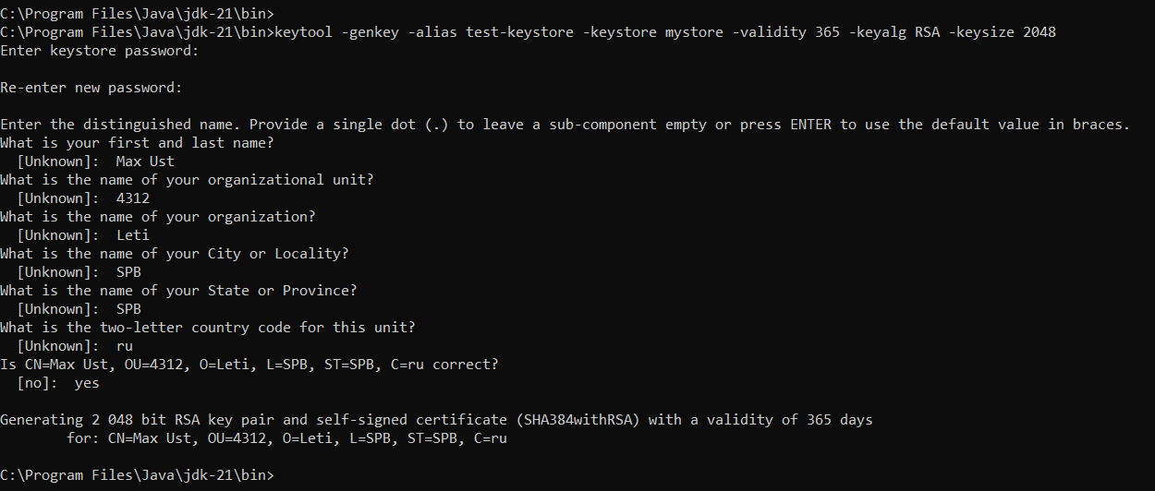
Рис. 1 – Скриншот, иллюстрирующий создание хранилища сертификата.

Скриншот работы приложения.
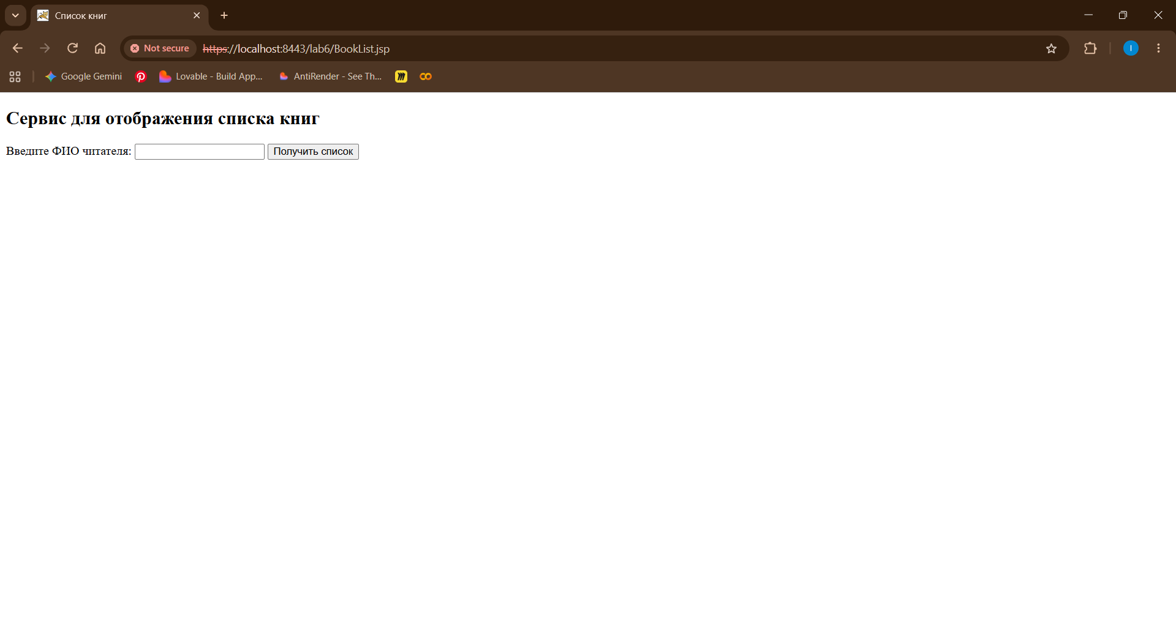
Рис. 2 – Скриншот работы приложения.
Выводы.
В ходе выполнения лабораторной работы были успешно освоены методы реализации аутентификации и авторизации пользователей web-приложения. Для разграничения прав доступа была настроена базовая HTTP-аутентификация, включающая определение ролей и учетных записей в конфигурации сервера Tomcat. С помощью дескриптора развертывания проекта были защищены конкретные web-ресурсы и заданы строгие ограничения доступа на основе назначенных ролей. Для обеспечения безопасной передачи данных по сети был сгенерирован криптографический ключ и создано локальное хранилище сертификатов с использованием утилиты keytool. На основе созданного хранилища был настроен защищенный коннектор сервера, что позволило перевести работу приложения на зашифрованный протокол HTTPS. Итоговое тестирование подтвердило корректную работу всех механизмов: сервер безопасно устанавливает соединение и успешно авторизует пользователей перед предоставлением доступа к закрытым страницам.

